CSEE W4840 Embedded Systems
The Idaho Trail: A Custom Implementation of the Classic Video Game The Oregon Trail
Final Report
Prepared for Professor Stephen A. Edwards

Adam Auer – aha2197
Xingcan “Ricardo” Chen –xc2807
Sunny Qi –sq2284

Columbia University
13 May 2026
____________________________________________________

Introduction
Motivation
Ever since the first mainstream computer games were developed in the 1970s, the most engaging, thought-provoking, and immersive have (quite arguably) been of the roleplaying genre. Such games invite players to see themselves in the protagonist in a way that others do not: instead of simply controlling the character’s movements in predictable static environments, players make choices that affect the game’s story, world, and ultimate end state.
We three grew up playing roleplaying games. The Witcher, Mass Effect, and Cyberpunk 2077 have hundreds of hours played in our collective Steam libraries, a product of their incredible power to enthrall players through deep character customization, explorable worlds, unique situations, and difficult ethical decisions. We yearned to share our passion for roleplaying games through our Embedded Systems Project; after hours of research and discussion, we settled on a custom implementation of the timeless classic The Oregon Trail.

Why The Oregon Trail?
The Oregon Trail’s greatest allure was the relative lack of expectation associated with it. When people think of Pacman, for example, they have a very rigidly defined vision for the game: a mouthed yellow ball traversing a maze of blue lines, attempting to consume all the white dots on the screen before being killed through contact with a brightly-colored ghost. The Oregon Trail has been re-implemented so many times over the years, though, that there is no single popular vision of what an Oregon Trail game should be. It began in the 1970s as a text-based game developed for a high school mainframe, was re-implemented in the 1980s with color graphics and expanded gameplay, and was even made into a touch-based game for early smartphones in the 2000s. Free of the constraints of a rigid formula, we took confidence in the idea that we could make the game our own. It could turn out as a rather extravagant project with smooth animations and branching story paths, or it could be a more stripped-down version that demonstrated our prowess with C and Verilog through only a few basic mechanics.
Another advantage we saw in The Oregon Trail was its heavy reliance on text. People might have different ideas of the game’s graphics and difficulty based on the version they played growing up, but they would all agree that The Oregon Trail is a “spreadsheet game.” The focus isn’t really on the graphics; it’s on the numbers expressing the player’s chances of success and the humorous situations described in textual narration. We as a group were wary of committing ourselves to a too complicated, graphically-intensive assignment that would require hours of developing artistic sprite designs and the mechanisms to make them move. The Oregon Trail was the perfect project for starting simple and adding complexity over time, and it offered us the challenge of rendering several lines of text alongside graphics on the screen, something that other popular projects like Pacman and Minesweeper simply don’t do.
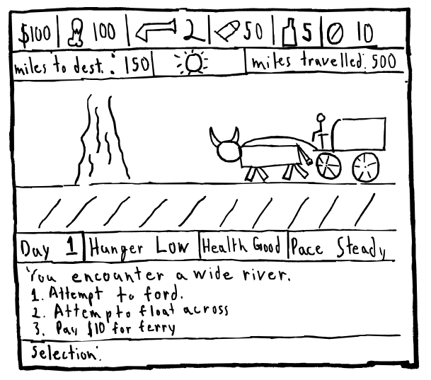
Fig. 1: Early concept sketch

Initial Vision
Our initial vision for the game was rather ambitious. We envisioned the player managing several critical variables, including foodstuffs, guns, ammunition, medicine, spare wheels, weather, and pace, each of which would have different effects on the chance of surviving a multitude of random events. We also envisioned something of a branching side narrative involving a fellow party member making advances on the protagonist’s wife, with the player at some point having the option to kill or spare him.
We quickly realized that such a project was far too ambitious for the limited time we had. We pivoted to a much more stripped-down version with only a few stats for the player to manage, a few events, and a few images to excite the player’s imagination. Instead of spending hours on game logic and art, we decided that it was more important to focus on developing the custom hardware and software that would allow us to efficiently draw player stats, animated images, narrative text, and a decision prompt to the screen simultaneously.
Big-Picture Block Diagram
Before diving into the details of our implementation, it is useful to begin with a block diagram representing the overall structure of the project.
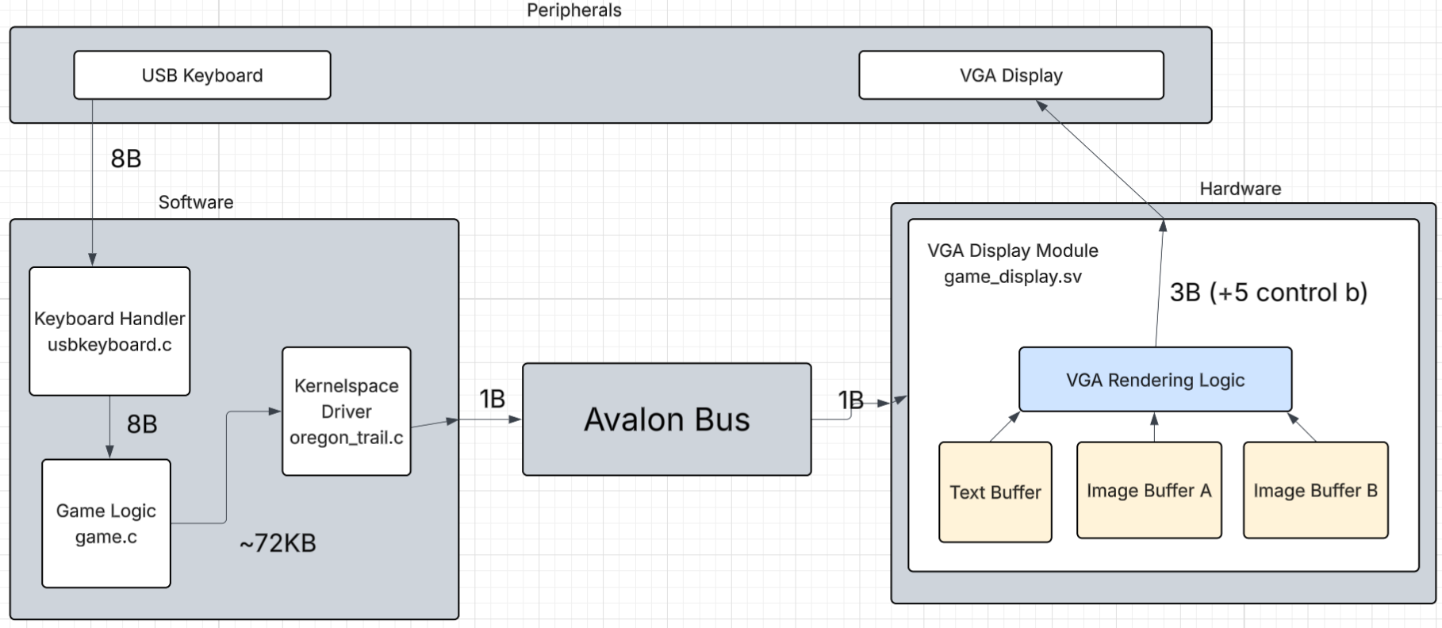
Fig. 2: Big picture block diagram; values represent the size of data passed between components, in bytes (except for the 5 control signals output from VGA Display Module, shown in bits)

Summary
- Peripherals
  - USB keyboard–sole method of user input; for our implementation, only the keys 1-9 are used; all others are ignored
  - VGA display–sole form of output; displays pixels in a 640x480 grid
- Software
  - Keyboard Handler–keyboard inputs are received and interpreted by libusb, managed in userspace by code in usbkeyboard.c; our game logic code in game.c uses usbkeyboard.c/libusb as an intermediary
  - Game Logic–the logic for managing the player’s stats and displaying text and images on the screen, written in game.c; interacts with the hardware via the Kernelspace Driver
  - Kernelspace Driver–directly drives the hardware based on data received from the Game Logic; uses iowrite8() to send data over the Avalon bus; writes data into the Text Buffer and both Image Buffers; pixel data is only written to one Image Buffer at a time
- Avalon Bus–transafers data from our Kernelspace Driver to our hardware
- Hardware
  - VGA Display Module–hardware logic for driving the VGA display, described in oregon_trail.c; converts pixel data in the Text Buffer and 8bpp image data in the Image Buffers to the 3 VGA color signals; pixel data is only read from one buffer at a time, whichever one the Kernelspace Driver is not writing to

Display Division
The issue that most radically influenced our later design decisions was the question of how to divide the VGA display into distinct regions for displaying characters and images. We initially devised a rather complicated scheme with different BRAM buffers for the narration box, player prompt, and stat boxes; SDRAM-backed image buffers; and binary to ASCII numeral conversion performed at the hardware level. With the help of Prof. Edwards, though, we developed an ingeniously simple display scheme that greatly simplified our Verilog code.

Physical Layout
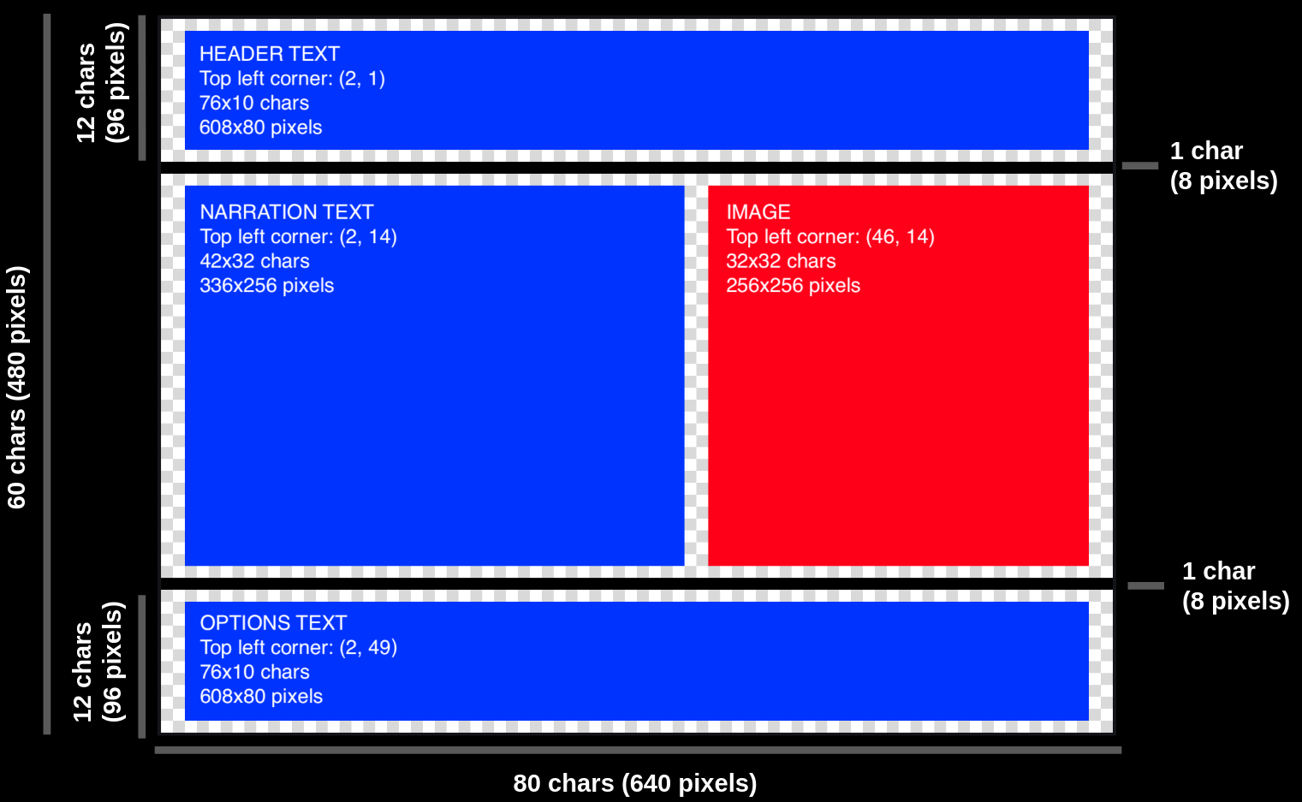
Fig. 3: On-screen layout of our various text and image regions; text regions in BLUE, image region in RED

Here, we show our distinct regions for drawing text and image data as they appear to the player:
- Header Text: displays day number, player health, and player food; extends from one end of the screen to the other
- Narration Text: informs the player of what is currently happening within the game world; extends from the left edge of the screen to the image, which begins at the 39th character column (i.e., where the 49th character in the row would be) and the 385th pixel column
- Image: represents the game world through a hand-drawn image
- Options Text: lists the keys associated with each available player action
- checkerboard: always-empty padding rows and columns

Logical Layout (Buffers)

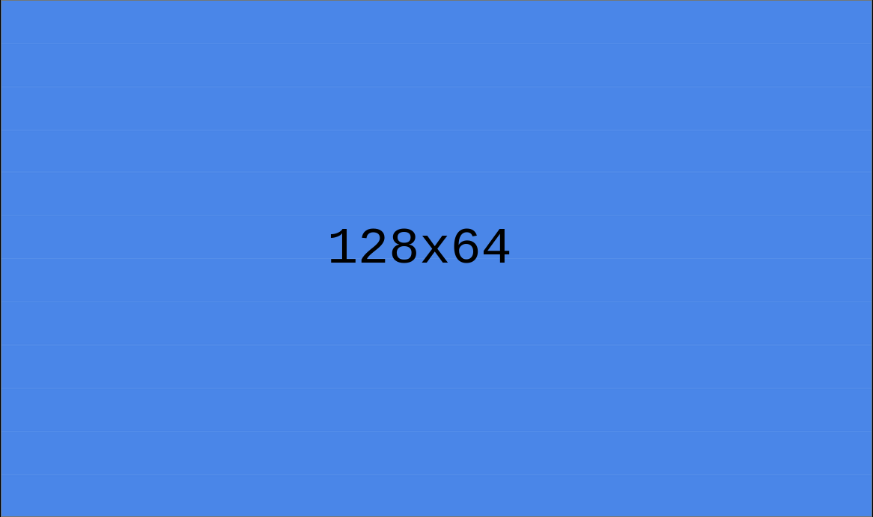
Fig. 4: Text buffer
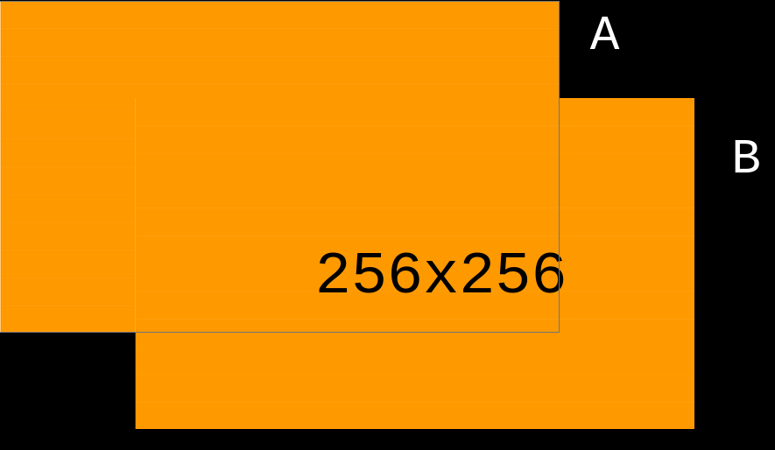
Fig. 5: Display buffers (A and B)
Here, we demonstrate our scheme for storing text and image data at the hardware level.
Instead of maintaining different buffers, we maintain a single, 8KB array of ASCII characters describing the text for the entire screen. To access a character at a specific row and col on the screen, we use the formula $arrayIndex = row *NCOLS + col$. Because the number of columns is a power of two, the multiplication and addition simplifies to a bitwise concatenation at the hardware level. Deriving row and col from arrayIndex similarly becomes a bitwise separation of low and high bits. Using an 8x8 font, our display only supports 128 columns and 60 rows of characters, but we simply avoid printing to the “extra” cells or to cells where we know the image to be.
For our image data, we similarly maintain two 64KB buffers, each with exactly enough space to describe a 256x256 (in pixels) image in 8 bit color (RRRGGGBB). Unlike for text, we do use the entire buffer to hold data for the physical screen. These buffers do not cover the entire screen, so we simply take the first column of an image buffer to correspond to the 385th pixel column of the display (with the single exception of the “start” state, when the image is centered). To prevent visible tearing when changing the visible image, our software always writes into the buffer that is not currently displayed.

Buffer Memory Locations
For simplicity, the image and text buffers are allocated in hardware as MK10 memory blocks. The driver can then use iowrite8() to write to effectively draw to the screen directly, avoiding the additional layers of abstraction that would be introduced using SDRAM. Because our images are only 64KB each, the 496KB of BRAM available on the Cyclone V De1-SoC is more than sufficient.

Gameplay Loop
After realizing our initial vision involved far too much coding not directly related to the principles learned in this class, we drastically simplified our gameplay loop to focus on implementing the core elements of The Oregon Trail in a manner resistant to edge-cases.

Core Gamestate Structure
Within our userspace C code, the player’s states are recorded by the following struct:
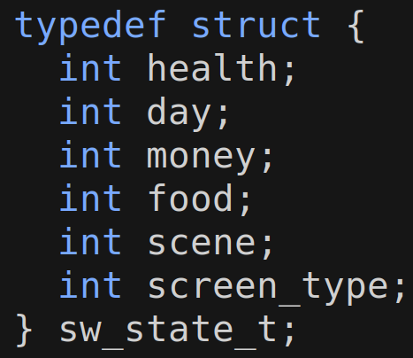
Fig. 6: Core player state struct

Intuitively, each integer represents how much a player has of that thing. The one restriction is that each must be representable as an at-most-3-digit, positive number when they are printed, and our game logic simply prevents them from becoming too large or too small. Somewhat counterintuitively, health increases as a player’s health worsens.
Main Gameplay Loop

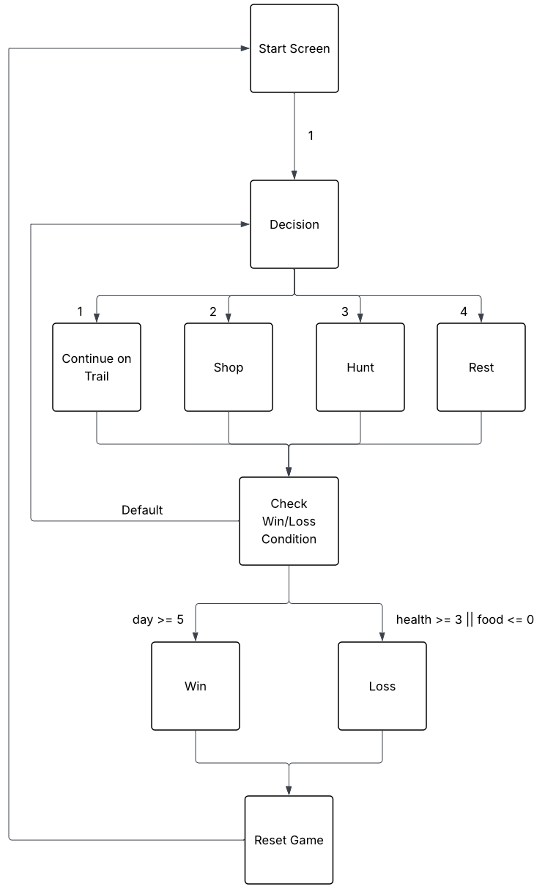
Fig. 7: Gameplay loop diagram
Gameplay State Summary
For all states described, any input other than a valid input is completely ignored. For all states other than the start screen, the image is shown on the right center side of the display.
- Start Screen
  - The start screen appears in the center of the display. The player may press 1 to continue to the first Decision screen.
- Decision
  - The player may press 1, 2, 3, or 4. A different event then occurs based on the user’s input.
  - Show main trail image
- Continue On Trail
  - day += 1
  - food -= 3
  - health += 1
  - show animation
    - exchange two “animation frames” back and forth, three times
- Shop
  - Enter the shop loop
  - User may choose from the following inputs:
    - 1. purchase food
      - 1-9 pounds, at 1 money per pound
    - 2. purchase medicine
      - 1 unit, at 10 money per unit
      - upon purchase, improves health by one degree
    - 3. exit the shop
  - The player may continue to purchase food and medicine until the player elects to exit the shop
  - Show shop image
- Hunt
  - food -= 3
  - generate random 0, 1, or 2
    - 0: fail (with no penalty)
    - 1: food += 5
    - 2: health +=1 (worsening health)
  - Show hunt image
- Rest
  - food -= 3
  - health -= 1 (that is, health improves by 1)
  - Show rest image
- Check condition
  - if health >= 3, food <= 0, then loss
  - Otherwise, if day >= 5, then win
- Loss
  - Show loss image
  - After 5 seconds, return to start screen
- Win
  - Show win image
  - After 5 seconds, return to start screen

Reading User Input
For simplicity, we strictly used libusb to read player inputs from a basic USB keyboard. libusb passes data to userspace programs in the following structure:
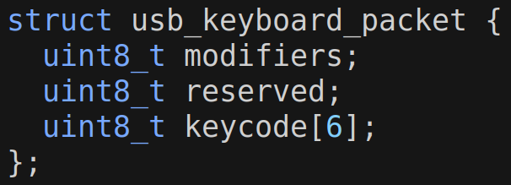
Fig. 9: Core structure used by libusb to describe keyboard inputs

Our code in game.c receives this structure, takes keycode[0], and subtracts 0x1D to convert the keypress to one of the digits 0-9 (assuming the key pressed was one of the 1 to 9 keys).

Edge Case Resilience
All invalid inputs at any point in the game are simply ignored. To prevent unexpected behavior resulting from a player holding keys or attempting to enter multiple inputs simultaneously, we wrap libsub_usb_transfer() in a custom get_key() function. getkey() waits for all keys to be released before returning and returns the integer corresponding to the digit key that was pressed earliest. Keypresses for letters and special characters are ignored. The shift keys are also ignored, so Shift+1, for example, will be interpreted as an input of ‘1’ and not ‘!’.

Avalon Configuration
To demonstrate how our software and hardware components fit together on the physical Cyclone V De1-Soc, we present screenshots from Intel Platform Designer.
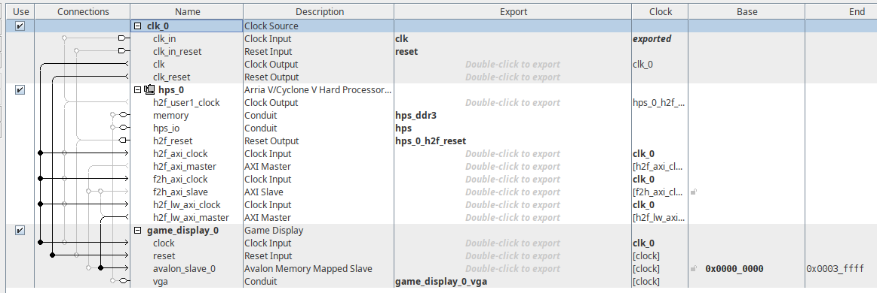
Fig. 10: Avalon system components
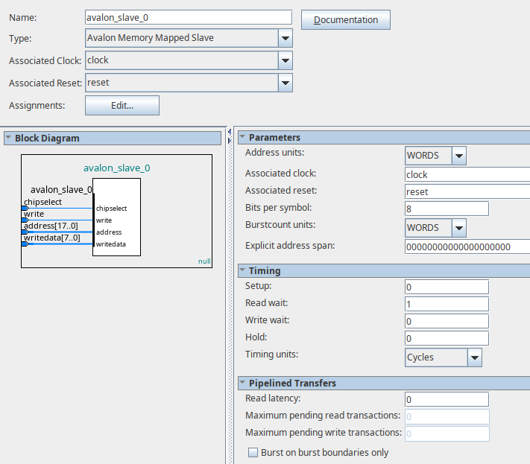
Fig. 11: Software-hardware Avalon interface
System Components
- clk_0
  - provides clock (50 MHz) and reset signals
  - drives the inputs of hps_0 and game_display_0
  - In game_display.sv, we set VGA_CLK to clk, so our VGA output pulses at 50 MHz (it is “double-pumped”)
- hps_0
  - ARM Cortex-A9 hard processor
  - runs our custom C code, including our Game Logic (game.c) and Kernelspace Driver (oregon_trail.c)
- game_display_0
  - custom Avalon memory-mapped slave
    - receives input to the avalon_slave_0 input from hps_0’s h2f_lw_axi_master
  - behavior governed by our custom hardware code

Software-Hardware Avalon Interface
avalon_slave_0 serves as the interface between software and hardware, receiving input from hps_0 and setting inputs within game_display_0, an instance of our game_display hardware module defined in game_display.sv. When the Kernel Driver calls iowrite8(), it passes in an address and a single byte of data, which then appear at the address and writedata inputs of avalon_slave. The chipselect and write inputs round out the interface, respectively asserting that the memory-mapped region assigned to the Avalon slave is currently being accessed and that the Avalon slave should read in the current value at the writedata input (which is periodically garbage).
As shown under the “parameters” panel, we chose an 8-bit wide interface for passing data from driver to hardware. Because the driver’s primary role is to set 8-bit ASCII characters in the character buffer and 8-bit pixel colors in the image buffers, an 8-bit wide interface is sufficient and simplifies our hardware and software logic. A possible future optimization would be to expand the interface to 16 or 32 bits, allowing us to write multiple pixels or characters simultaneously and avoid the overhead of extra writes over the Avalon Bus.

Register Map

Offset | Size | Name | Type | Access | Desc.
0x00000 | 1B | CONTROL | boolean | R/W | 0 = blank screen  1 = screen on
0x00001 | 1B | SCREEN_TYPE | boolean | R/W | 0 = right-side image  1 = center image
0x00002 | 1B | ACTIVE_BUF | boolean | R/W | 0 = display from buf. A  1 = display from buf. B
0x0003-0x01FFF |  | unmapped
0x02000-0x03FFF | 8KB | TEXT_GRID | M10K BRAM | W | 128x64 ASCII character grid
0x04000-0x0FFFF |  | unmapped
0x10000-0x1FFFF | 64KB | IMAGE_A_BUF | M10K BRAM | W | 256x256 8bpp image grid
0x20000-0x2FFFF | 64KB | IMAGE_B_BUF | M10K BRAM | W | 256x256 8bpp image grid
Fig. 12: Register map

Our Kernelspace Driver controls the behavior of game_display_0 by writing to the memory offsets shown in the above register map through avalon_slave_0. By virtue of our simple three-buffer display scheme, our register map is wonderfully concise. Below, we describe the function of each memory region, or register, in some detail:
- CONTROL
  - Controls whether the screen is on or off
  - 0: the values of the R, G, and B signals are set to 0 each clock cycle, making the VGA display black
  - 1: the R, G, and B signals are set based on the values in the Text Buffer and the currently-active Image Buffer
- SCREEN_TYPE
  - 0: the image is displayed at the right-center edge of the VGA display; used throughout the entire game, except for the start screen
  - 1: the image is displayed in the center of the VGA display; used only for the start screen
- ACTIVE_BUF
  - The lynchpin of our double-buffered image display scheme
  - 0: R, G, and B signals are set based on the data in Image Buffer A
    - Kernelspace driver should write to Image Buffer B
  - 1: R, G, and B signals are set based on the data in Image Buffer B
    - Kernelspace driver should write to Image Buffer A
- TEXT_GRID
  - Our text buffer, allocated as seven M10K BRAM blocks
  - Represents 128x64 ASCII character grid (1 character = 1 byte)
  - Given 0-indexed row and col, the index for a character in the grid is:
    - $arrayIndex = row*128+col$
- IMAGE_A_BUF
  - Our first image buffer, allocated as fifty-two M10K BRAM blocks
  - Represents a 256x256 grid of bytes, where each byte describes the color of the corresponding pixel as RRRGGGBB
- IMAGE_B_BUF
  - Our first image buffer, allocated as fifty-two M10K BRAM blocks
  - Represents a 256x256 grid of bytes, where each byte describes the color of the corresponding pixel as RRRGGGBB
Memory Inventory

 | Size | Location | Desc.
Font | 1 KB (128*8*1) | BRAM  (1 block) | Loaded at synthesis time; used to draw characters
Image Buffer A | 64 KB (256*256) | BRAM  (52 blocks) | Holds image for display or write
Image Buffer B | 64 KB (256*256) | BRAM  (52 blocks) | Holds image for display or write
Text Buffer | 8 KB (128 * 64) | BRAM  (7 blocks) | Holds text data; simultaneous read/write
Image Data (.hex) | 192 KB | HPS Memory | Loaded on-demand by software
Fig. 13: Memory inventory

In Fig. 13, we present our most significant memory allocations within on-FPGA and on-HPS memory. On the FPGA, the Image Buffers are by far the largest memory-users, taking up 64 KB each. At the beginning of this project, we considered making the displayed image fill the entire width of the screen and half the height, or 640x240 pixels, and representing the images in 16-bit color. Each image buffer would have then taken up 300KB, and the two buffers would have used 600KB of memory total. The Cyclone V De1-SoC comes with only 496KB or BRAM, so our only recourse would have been to place our image buffers in SDRAM, which would have added significant complexity and computational overhead. We thus scaled our images down to 256x256 and switched to 8-bit color, leaving us with a plentiful amount of additional memory should we have needed it later.
Not shown on the Register Map but nonetheless allocated in BRAM is our font data, which describes the shape of each glyph. Our font contains 128 glyphs corresponding to the 128 ASCII characters, and each glyph is 8x8 pixels. For each glyph, the font contains 8 rows of 8 bits, with a 1 indicating space filled by the drawn character. The full font is thus 128 glyphs * 8 bytes/glyph, or 1KB. At synthesis time, the entire font is loaded from disk by a readmemh command and compiled into the output .sof file. During FPGA configuration, the font is loaded into BRAM, where it can be quickly accessed by our custom hardware.
One final point of interest is that the largest demand our Game Logic places on HPS memory is to hold a single 192KB .hex file describing an image being loaded for display. Instead of converting images from .png to raw binary 8bpp values at runtime, which would waste computational resources unnecessarily, we store images on our SD card in .hex format, where each line of two hexadecimal characters describes a single pixel’s color. The hex characters are loaded from disk and parsed into binary whenever an image is needed at runtime, which is only modestly expensive. A potential optimization would be to parse each image into binary pixel data and store it in memory at the start of the Game Logic program (game.c), but our displayed image is updated infrequently enough that this is unnecessary. Converting images to binary pixel data ahead-of-time and saving the resulting .bin files to disk would eliminate the instructions needed for the just-in-time parse step, but keeping images on disk in .hex eases interpretation by humans and LLM’s and thus accelerates debugging.
Drawing Text to the Screen
The display controller renders text using a character-based text buffer together with a font ROM. Instead of storing individual text pixels, the software writes ASCII character codes into a dedicated text memory region through the Avalon memory-mapped interface. This greatly reduces memory usage compared to storing full bitmap text images. As mentioned previously, the entire font file is loaded into the .sof file at synthesis time via a single readmemh() call in game_display.sv.
The text buffer is implemented using BRAM. Each memory entry stores one 8-bit ASCII character. The display hardware continuously scans the text buffer while generating VGA output. The text memory is organized as rows of 128 characters per line, although only the first 80 columns are actively displayed. This simplifies address generation because the character row address can be computed using a left shift operation rather than multiplication.

For every visible VGA pixel, the hardware first converts the current VGA scan position into a logical 640×480 coordinate system. The horizontal scan coordinate is divided by two because the VGA timing generator operates at 1280 horizontal pixels while the game internally uses a 640 pixel wide coordinate space.
The corresponding ASCII character is read from text BRAM. The hardware then combines the ASCII value with the current vertical pixel offset inside the character cell to form an address into the font ROM. The font ROM stores one byte per character row, where each bit represents whether a pixel should be illuminated.
The font data is read through a small pipeline. The selected font bit corresponding to the current horizontal offset determines whether the current pixel belongs to the foreground character.
If the font bit is active, the display controller outputs a white pixel. Otherwise, the pixel is treated as transparent, allowing the image layer behind the text to remain visible. Space characters are also treated as transparent to simplify overlay rendering.
Drawing Images to the Screen
Images were initially generated as .png files using the image-creation tools available on pixilart.com. All images but one, the “shop” image displayed during the shop loop, were custom-made. Credit to the shop image (market.png) goes to pixilart user @DgGamez.

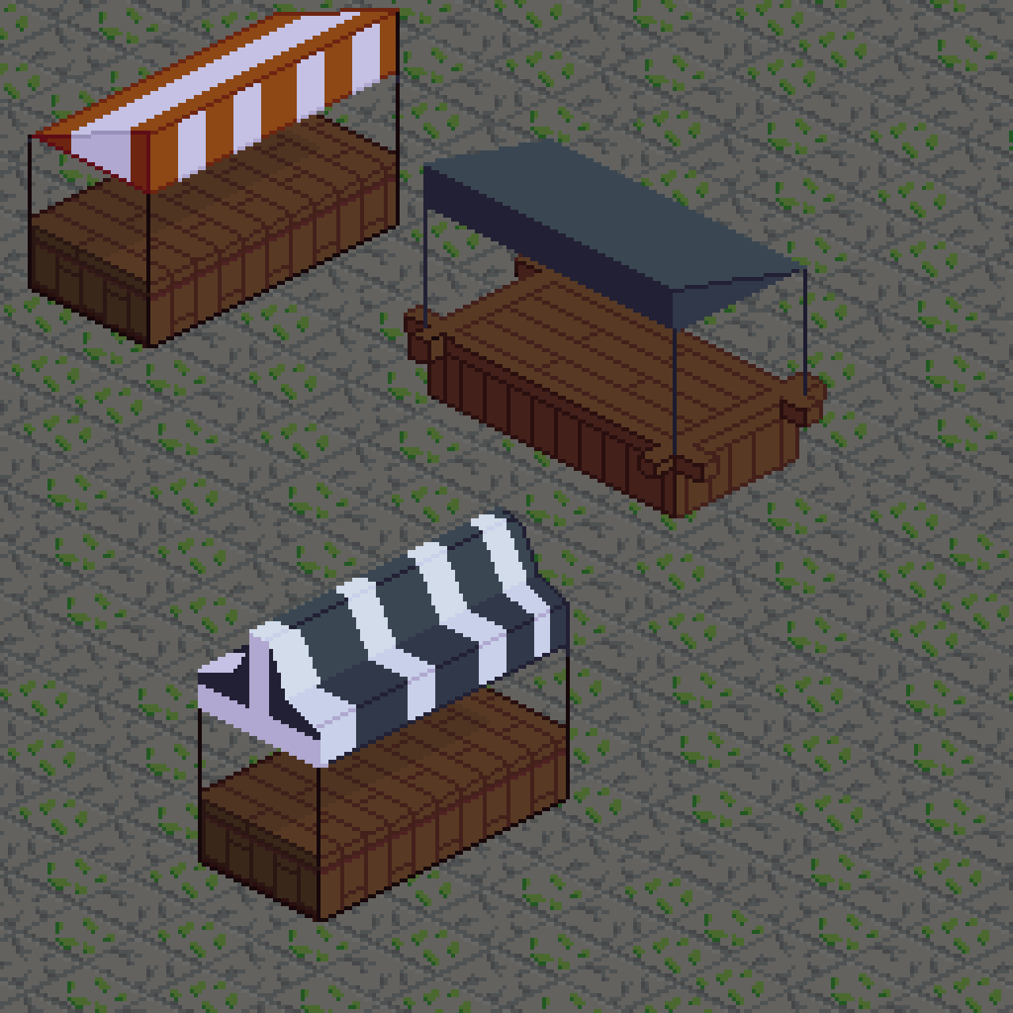
Fig. 14: market.png; credit to @DgGamez
Images were then converted to a .hex file using our png_to_hex.py script. Each line of the output hex file contains the 8-bit (RRRGGGBB) color data for one pixel of the final 256x256 pixel image.
The software writes pixel data into the inactive BRAM buffer through the Avalon memory interface. After the new image is fully written, the software switches the active buffer by updating the active_buf.
During VGA scanout, the display controller converts the current screen position into local image coordinates and calculates the image memory address:
$imageAddr = y*256+x$
The hardware supports two display modes. In centered-image mode, the image is drawn in the middle of the screen(the size is still 256*256, what has been changed is the position). In gameplay mode, the image is drawn on the right side while the left side is used for text and status information.
The selected image pixel is read from the active frame buffer and expanded into VGA RGB signals. Text pixels have priority over image pixels. Pixels outside the visible display region are forced to black.

Lessons Learned
- Carefully managing memory usage to avoid unexpectedly overusing BRAM
- How userspace code, kernelspace code, and hardware connect through calls to ioctl() and iowriteN()
- Properly communicate with the hardware using the register map
  - The register map should be one of the first things to finish!
- Do it the easy way: instead of writing into many small BRAM buffers, could we instead write into only a few large buffers
- Generating VGA signals in System Verilog based on multiple, potentially overlapping sources of pixel data
- Using LIBUSB to read key presses
  - Address various input bugs
    - Pressing multiple buttons at the same time - forcing only the first button to actually go through
    - Preventing keypresses during sleeps to affect later input (flush keyboard before you receive a new input)
- Carefully consider the sort of physical hardware that the System Verilog code will generate; avoid unnecessary multiplication and division by arbitrary integers; aim for powers of two
- Focus on delivering a “minimum viable product,” then try to improve upon that; don’t be too ambitious at the start

Individual Contributions
- Sunny Li
  - Basically all software-sided code
  - Implemented entire SW side ioctl logic
    - Size and offsets of all the registers to be sent
  - Handled keyboard input reading and debugging
    - Fixed button mashing but (only first key pressed is registered)
    - Fixed bug of old input (during sleeps) being read for next command (inputs are flushed upon every new decision)
  - Designed and detailed the specs for the 80x60 character grid
  - Ensured all the text inputs remained inside the proper defined bounds
  - Designed image loading logic on SW side
  - All game logic in C
- Ricardo Chen
  - Wrote code for game display hardware
  - Designed VGA display pipeline and framebuffer logic
  - Integrated FPGA hardware with Linux software
  - Debugged VGA timing, framebuffer addressing, and synchronization issues
  - Handled Quartus compile flow and final hardware demo integration
- Adam Auer
  - Drafted initial vision for the overall project
  - Drew and curated images for the game
  - Wrote png_to_hex.py script
  - Researched how to implement image double-buffering with BRAM and SDRAM
  - Helped Sunny and Ricardo debug their software and hardware code
  - Documented the team’s interfaces, memory usage, overall design, etc.
  - Wrote the majority of the presentation
  - Wrote the majority of this report

FMax timing summary
Static timing analysis was performed in Quartus Prime using the Slow 1100mV 85C timing model after full system integration.
The final design achieved:
- FMax: 99.19 MHz
- Restricted FMax: 99.19 MHz
- Clock domain:clock_50_1
Because the target system clock frequency was 50 MHz, the final implementation satisfied all timing constraints with significant timing margin remaining.
Flow Summary
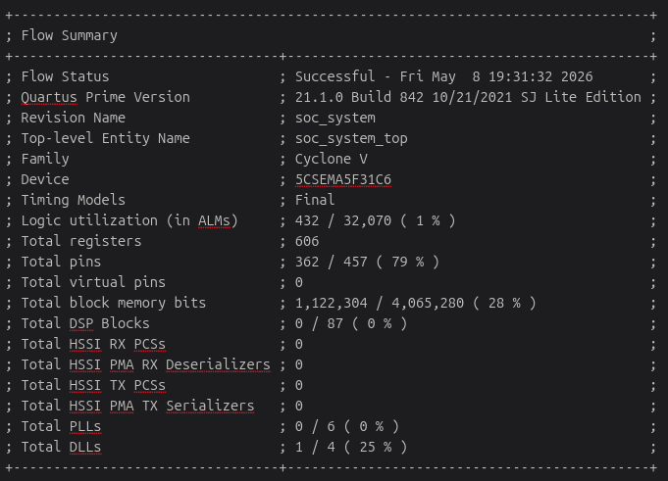
Fig. 14: Flow summary for our final generated hardware logic

Code

